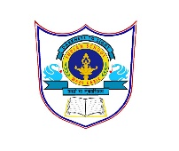
INDIAN SCHOOL ALWADI ALKABIR
DEPARTMENT OF SOCIAL SCIENCE
Final Examination: 2022-23
CLASS: VII Max: Marks: 80
Date: 14- 03 -2023 Time: 3 Hrs.
General Instructions:
- Ensure that you have written your name and roll number correctly.
- This Question paper has three parts, Section A (History) B (Civics) and C (Geography).
- All questions are compulsory
- Attach the Map along with your answer script.
- All the answers must be correctly numbered as in the question paper in the Answer sheet provided.
SECTION - A (HISTORY) 30 MARKS
I | Multiple Choice Questions: - | 2 Marks
1 | The perennial river Kaveri flows from.  a) Surat b) Thanjavur c) Uraiyur d) Vrindavan | 1 Mark
2 | The new political groups emerged in the subcontinent during the first half of the __________.  a) 18th Century b) 17th Century c) 15th Century d) 10th Century | 1 Mark
II | Fill in the Blanks: - | 1 Marks
3 | A tribal group which controlled large parts of the Brahmaputra Valley ___________. | 1 Mark
III | Match the Following: - | 2 Marks
4 | Sufi saint A) Agriculturists | 1 Mark
5 | Jats B) Kabul | 1 Mark
 | C) Khwaja Muinuddin Chishti
IV | Answer in One Sentence: - | 3 Marks
6 | How was water supplied to the city of Thanjavur? | 1 Mark
7 | What made the Brahmanas more influential in the Gond Society? | 1 Mark
8 | Why did the Nawab of Awadh and Bengal try to do away with the Jagirdari system? | 1 Mark
V | Answer in brief: - | 6 Marks
9 | Give an account of the architecture of Hampi. | 2 Marks
10 | Observe the picture and answer the questions below:-  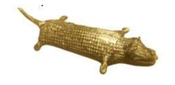  - Which metal is the crocodile made of?  - In which state was this crocodile found in. | 2 Marks
11 | How were peasant-pastoralists were important to Shivaji? | 2 Marks
VI | Answer the following: - | 6 Marks
12 | Why did people from distant lands visit Surat? | 3 Marks
13 | What were the policies adopted by Asaf Jah to Strengthen his position? | 3 Marks
VII | Answer in Detail: - | 5 Marks
14 | List the similarities between the Gonds and Ahoms.  OR  What were the changes took place in varna-based society? | 5 Marks
VIII | On the given outline map of India, locate and label the following places.  A) Ujjain B) Mewar C) Delhi D) Kannauj E) Nalanda | 5 Marks
SECTION - B (CIVICS) 20 MARKS
IX | Multiple Choice Questions: - | 2 Marks
15 | A programme which is transmitted widely in a Television or Radio is called as ___________.  a) Studio b) Publish c) Broadcast d) Technology | 1 Mark
16 | People elect or replace their representatives by using their power over ____________.  (a) Ballot Box (b) Government (c) Companies (d) Religion | 1 Mark
X | Fill in the Blanks: - | 1 Mark
17 | We can purchase goods through _________ without going to the markets | 1 Mark
XI | Match the following: - | 2 Marks
18 | Independent media A) Rallies, chakka jam etc | 1 Mark
19 | Creative expression B) Democracy | 1 Mark
 | C) Poems, song, paintings etc
XII | Answer in One Sentence: - | 3 Marks
20 | What do you mean by the term 'censorship'? | 1 Mark
21 | Define the term ‘Credit’. | 1 Mark
22 | On what basis are people discriminated? | 1 Mark
XIII | Answer in Brief: - | 4 Marks
23 | In what ways does media play an important role in a democracy? | 2 Marks
24 | Observe the picture and answer the questions below:  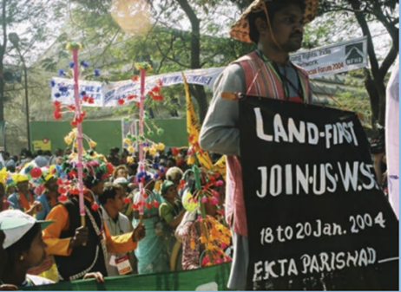 | 2 Marks
A) Name the caption given to this picture in the textbook.
B) How can the poems, songs or stories draw our attention on various issues?
XIV | Answer the Following: - | 3 Marks
25 | Why did the villagers set up Tawa Matsya Sangh? | 3 Marks
XV | Answer in Detail: - | 5 Marks
26 | How is the chain of markets set up?  OR  ‘Buying and selling can take place without going to a marketplace’. Explain this statement with the help of examples. | 5 Marks
SECTION - C (GEOGRAPHY) 30 MARKS
XVI | Multiple Choice Questions: - | 3 Marks
1 | Which type of rocks are called the primary rocks?  (a) Fossils (b) Igneous (c) Metamorphic (d) Sedimentary | 1 Mark
2 | The other name of the coniferous forests is  a) Taiga b) Tundra c) Mediterranean d) None of these | 1 Mark
3 | The Amazon Basin is the largest river basin in  a) America b) World c) Africa d) Australia | 1 Mark
XVII | Fill in the Blanks: - | 1 Mark
4 | The place where a building or a settlement develops is called its ________. | 1 Mark
XVIII | Match the Following: - | 2 Marks
5 | Fossils A) Toucans | 1 Mark
6 | Manioc B) Remains of the dead plants and animals | 1 Mark
 | C) Amazon
XIX | Answer in One Sentence: - | 3 Marks
7 | What are the three layers of the earth? | 1 Mark
8 | In which climatic conditions are citrus fruits cultivated? | 1 Mark
9 | What are the different kinds of activities practiced by the people in rural areas? | 1 Mark
XX | Answer in Brief: - | 4 Marks
10 | Limestone is changed into marble. Give reasons | 2 Marks
11 | Observe the picture and answer the questions given below:  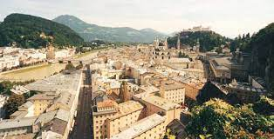  - Identify the picture  - Name the settlements which are occupied for a short period of time. | 2 Marks
XXI | Answer the Following: - | 9 Marks
12 | Draw and label the “Rock Cycle”. | 3 Marks
13 | ‘Today’s world is shrinking’. Give reason. | 3 Marks
14 | Describe the wildlife found in the Ganga Brahmaputra Basin. | 3 Marks
XXII | Answer in Detail: - | 5 Marks
15 | Describe the main features of Tropical Grasslands.  OR  Explain the uses of coniferous forest. | 5 Marks
XXIII | On the given outline map of the world, locate and label the following ocean currents.  A) Labrador Current B) Gulf Stream C) Mozambique Current | 3 Marks

